Assignment-6 EEC-3150 Engineering Programming II
- In the Blackboard Resources is a LinkedIn Learning course entitled Python Essential Training.

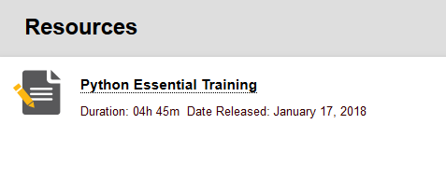
Review any lessons from the following chapters to increase your understanding:
Chapter 10: Exceptions
Chapter 13. Built-in Functions

You may choose any of the videos, or all of the videos that will increase your knowledge of the Python programming language. You are to enumerate three learnings from the videos you have selected. Each of the three learnings should be described in one or two sentences.

- In this exercise we will augment and enhance Assignment-5. Successful completion of Assignment-5 is necessary before undertaking this assignment. We will do the following:

Make the Python code more reusable. Create the following functions that are in separate modules (.py files) and import them into your main. The function names and module names will be the same. Function arguments flowing in to and from the functions will be as follows:
  - validate_ip_address (ip_addr_str)
in: a string that is an ip address candidate (e.g. w.x.y.z)
out: a six element tuple (e0, e1, e2, e3, e4, e5)

e0: a boolean representing validity of the ip address
e1: integer representation of ip address or 0 if boolean is false
e2: first octet of ip address as an integer or 0 if boolean is false
e3: second octet of ip address as an integer or 0 if boolean is false
e4: third octet of ip address as an integer or 0 if boolean is false
e5: fourth octet of ip address as an integer or 0 if boolean is false

  - validate_subnet_mask (subnet_mask_str)
in: a string that is a subnet mask candidate (e.g. w.x.y.z)
out: a two element tuple (e0, e1)

e0: a boolean representing validity of the subnet mask
e1: integer representation of subnet mask or 0 if error

- Define and discuss your black-box testing strategy for the Python code you have developed for this assignment. Your response should be at least 200 words. Be specific.

- Define and discuss your glass-box testing strategy or the Python code you have developed for this assignment. Your response should be at least 200 words. Be specific.

In addition, your script/program should have an informative header and comments throughout.
Submit: A file called Assignment-6-Results.docx to Blackboard.

